INSTRUCTIONS: Complete all pertinent data below and submit with the daily shift summary. PRINT ALL INFORMATION LEGIBLY.
Case Number: _______________ Report Date: ______________Report Time: ________________ Signal____
Address of Occurrence: ___________________ Rm Number: ____ Bldg/Location: _____________
Time of Occurrence (date/time): ______________Time Discovered (date/time): ________________
Building (if any):
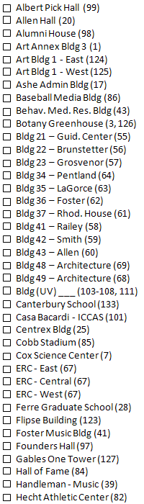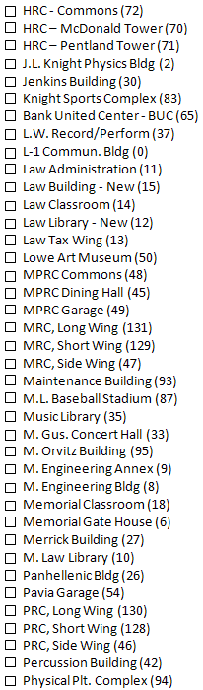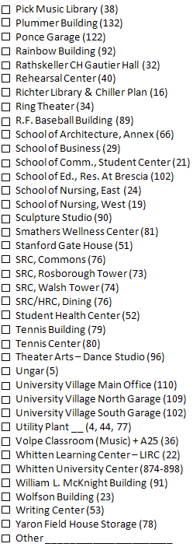

MO’s
Incident summary
Crime Scene
Crocodile sighting

Reporting Officer: _________________ Shift Commander submitting data form: _________________
